CHAPTER 3: SYSTEM ANALYSIS AND DESIGN

3.1 Introduction
This chapter presents a comprehensive analysis and design of the AutoAid system. It begins with a description of the adopted system development methodology and a feasibility study that evaluates the practicality of the proposed solution. The chapter proceeds to detail the requirements elicitation process, data analysis, system specifications, and requirements modelling. It concludes with the logical and physical design of the system, including the system architecture, database design, control flow, and user interface wireframes. The analysis and design artefacts presented in this chapter guided the implementation phase documented in Chapter 4.

3.2 Systems Development Methodology
AutoAid adopts a hybrid development methodology that combines the Cross-Industry Standard Process for Data Mining (CRISP-DM) framework with Agile software development principles. CRISP-DM provides a structured, iterative lifecycle for the machine learning components, guiding the process from business understanding through data preparation, modelling, evaluation, and deployment. Agile methodology governs the overall software development cycle, enabling iterative delivery, continuous testing, and incremental integration of system components.
The combination of these two methodologies was chosen because AutoAid is not a conventional software system. It integrates a mobile application, a RESTful backend, a relational database, and an intelligent ML inference engine. CRISP-DM ensures that the ML pipeline is developed rigorously and evaluated against defined performance criteria, while Agile practices enable the mobile and backend components to be built and tested in short sprints. This hybrid approach ensures that the system is developed in a structured yet flexible manner, accommodating changes in requirements and ML model performance as the project progresses.

3.3 Feasibility Study

3.3.1 Technical Feasibility
The proposed system relies on technologies that are well-established and readily available. FastAPI is a mature Python framework capable of serving ML models and RESTful APIs with high performance. PostgreSQL is a robust relational database system that supports geospatial queries through the PostGIS extension. Android development using Java is a well-documented field with extensive community support. The machine learning components, including NLP-based text classification and CNN-based image recognition, can be implemented using open-source libraries such as TensorFlow and scikit-learn. All required tools and frameworks are freely available, and the developer possesses the necessary technical skills to implement the system within the project timeline.

3.3.2 Economic Feasibility
The system was developed using exclusively free and open-source software tools, eliminating licensing costs. The development environment, including Android Studio, Python, PostgreSQL, and associated libraries, incurs no financial cost. The backend was deployed on a local development server during the prototype phase, removing the need for paid cloud infrastructure. For production deployment, low-cost cloud providers such as AWS Free Tier or Railway.app could be used at minimal cost. The system is therefore economically feasible for both development and small-scale deployment.

3.3.3 Operational Feasibility
The target users of AutoAid are vehicle owners in Kenya who own smartphones. Mobile phone penetration in Kenya exceeds 60% of the adult population, and Android devices constitute the majority of smartphones in use. The application is designed with a simple, intuitive interface that requires no prior technical knowledge. Garages can register through the application or through an administrator, making onboarding straightforward. The system operates over standard mobile data or WiFi connections, which are widely available in urban and peri-urban areas where the application is intended to be used. The system is therefore operationally feasible.

3.4 Requirements Elicitation

3.4.1 Data Collection
Requirements were gathered through a combination of interviews, observation, and questionnaire-based surveys conducted with vehicle owners and garage operators in Nairobi. A structured questionnaire was administered to twenty vehicle owners to understand their experiences with vehicle breakdowns, current diagnostic practices, and willingness to use a mobile-based diagnostic tool. Semi-structured interviews were conducted with five garage operators to understand their service offering, capacity, and interest in being listed on a digital marketplace. Observations were made at roadside breakdown scenarios to understand the time and resources required to obtain assistance.
The questionnaire was designed to elicit information on the frequency of vehicle breakdowns, the most common types of faults encountered, the channels currently used to seek repair services, and the perceived usefulness of an intelligent diagnostic application. The data collected was analyzed using descriptive statistics and visualized using bar charts and pie charts, as presented in Section 3.5.

3.4.2 Sampling
A purposive sampling technique was used to select respondents who own personal vehicles and have experienced at least one breakdown in the past two years. The sample size of twenty vehicle owners was selected based on the scope and timeline of the prototype evaluation. For garage operators, a convenience sample of five operators based in Nairobi was used. The small sample size is acknowledged as a limitation of the study and is appropriate for a proof-of-concept evaluation.

3.5 Data Analysis
The data collected from the survey was analysed to identify the most common vehicle faults, user preferences, and pain points in the current process of seeking repair services. The findings are summarised below.

Figure 3.1 shows the distribution of the most frequently reported vehicle fault categories among the surveyed vehicle owners.
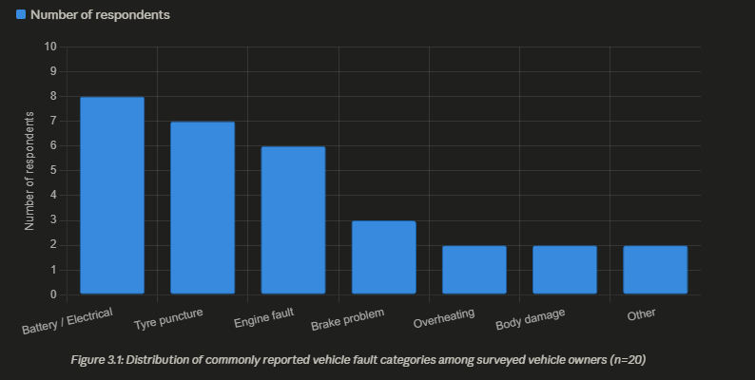

Figure 3.1: Distribution of commonly reported vehicle fault categories among surveyed vehicle owners

The analysis revealed that battery-related faults, tyre punctures, and engine issues were the three most commonly reported fault categories, accounting for approximately 65% of all reported incidents. Brake faults were reported by 15% of respondents and were consistently described as the most urgent and dangerous category of fault. Body damage, ignition failures, and suspension issues accounted for the remaining 20%.
Figure 3.2 illustrates the methods currently used by vehicle owners to seek diagnostic information when their vehicle breaks down.

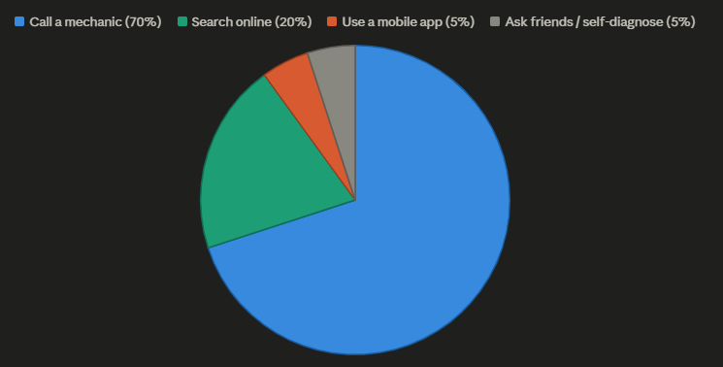
Figure 3.2: Methods currently used by vehicle owners to diagnose vehicle faults

The data showed that 70% of respondents call a known mechanic directly, while 20% search online for symptoms. Only 5% use a dedicated automotive application, and the remaining 5% attempt to diagnose the fault themselves. This finding confirms the research gap identified in Chapter 2: no mobile-first, intelligent diagnostic tool is currently in widespread use among Kenyan vehicle owners.
All five garage operators interviewed expressed interest in being listed on a digital marketplace, provided the registration process was straightforward and did not require technical expertise. They also indicated that receiving advance information about a customer's diagnosed fault category would improve their ability to prepare for the repair, reducing waiting times for customers.

3.6 System Specification

3.6.1 Functional Requirements
The following functional requirements were derived from the data collection and analysis:
- The system shall allow users to register and log in securely using an email address and password.
- The system shall allow authenticated users to submit a text description of their vehicle fault and receive a ranked list of probable diagnoses with confidence scores and urgency levels.
- The system shall allow users to optionally attach an image of the vehicle fault during diagnosis submission.
- The system shall allow users to optionally attach an audio recording of the vehicle sound during diagnosis submission.
- The system shall store all diagnostic records associated with a user's account for future reference.
- The system shall allow users to register one or more vehicles to their profile.
- The system shall use the user's GPS location to retrieve a ranked list of nearby garages.
- The system shall rank garages based on distance, specialisation match to diagnosed fault, and user rating.
- The system shall allow users to view garage details including address, phone number, specializations, price range, and opening hours.
- The system shall allow users to book a garage visit, request on-site mechanical assistance, or request towing services.
- The system shall allow garage operators and administrators to update booking status.
- The system shall send push notifications to users when a booking is confirmed or its status is updated.
- The system shall allow authenticated users to rate a garage after service.

3.6.2 Non-Functional Requirements
- Performance: The diagnostic API endpoint shall return a response within three seconds for text-only inputs under normal network conditions.
- Usability: The user interface shall be operable by a non-technical vehicle owner without prior training.
- Security: All API endpoints shall require JWT-based authentication. Passwords shall be stored as bcrypt hashes.
- Reliability: The backend server shall handle concurrent requests from multiple users without degrading response time significantly.
- Scalability: The system architecture shall support horizontal scaling of the backend service.
- Portability: The Android application shall support devices running Android API level 26 (Android 8.0) and above.
- Maintainability: The backend codebase shall follow a modular structure with clearly separated concerns for routing, services, and data access.

3.7 Requirements Analysis and Modelling

3.7.1 Use Case Diagram
The use case diagram in Figure 3.3 illustrates the interactions between the primary actors and the AutoAid system. The three primary actors are the Vehicle Owner (the main end user), the Garage Operator (a registered mechanic or garage manager), and the System Administrator.

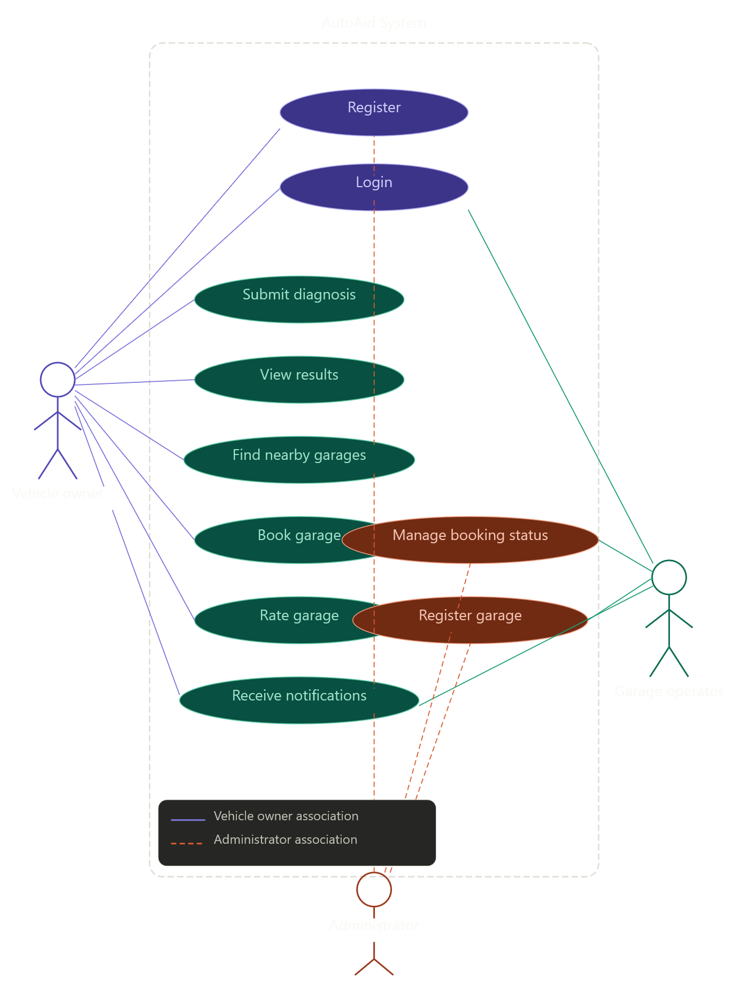
Figure 3.3: Use Case Diagram for the AutoAid system

The Vehicle Owner can register, log in, submit a diagnosis, view diagnostic results, find nearby garages, book a service, rate a garage, and receive notifications. The Garage Operator can register a garage, view and update booking statuses, and receive booking notifications. The System Administrator can manage all garages, users, and bookings through the API.

3.7.2 Context-Level Data Flow Diagram
Figure 3.4 presents the context-level Data Flow Diagram (DFD), which shows the AutoAid system as a single process and its interactions with external entities.

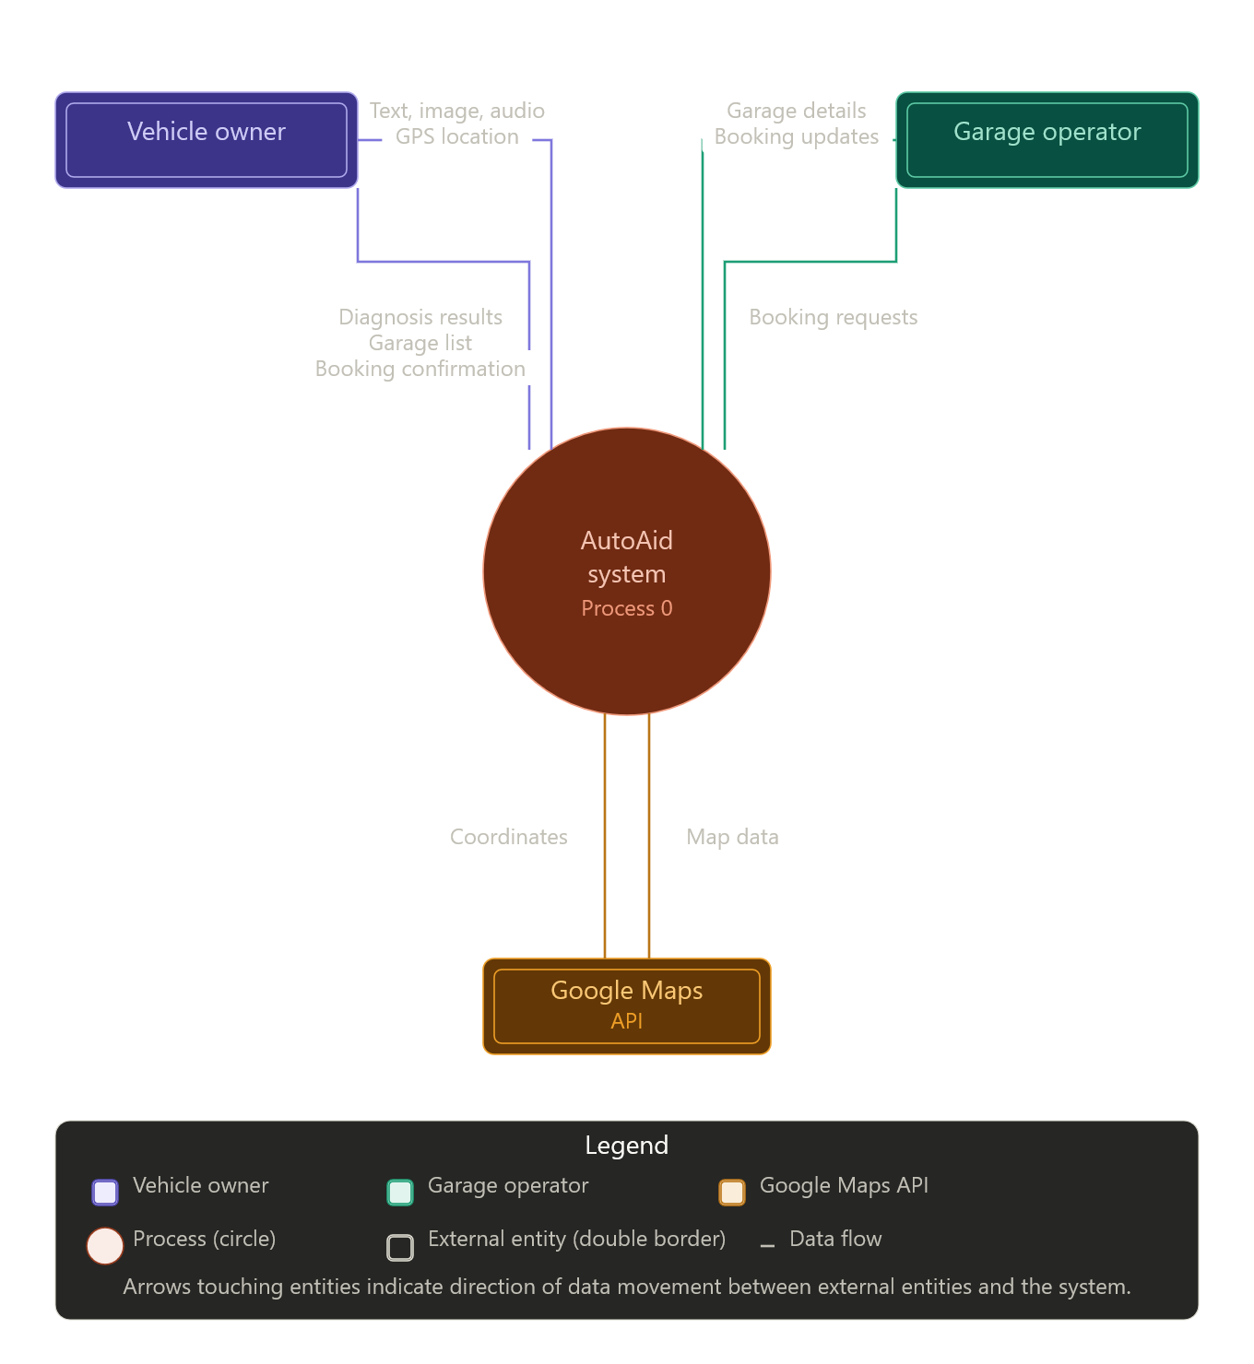
Figure 3.4: Context-level Data Flow Diagram (Level 0) for the AutoAid system

3.7.3 Level-1 Data Flow Diagram
Figure 3.5 expands the context DFD into its major processes: User Authentication, Multimodal Diagnosis, Garage Discovery, and Booking Management.

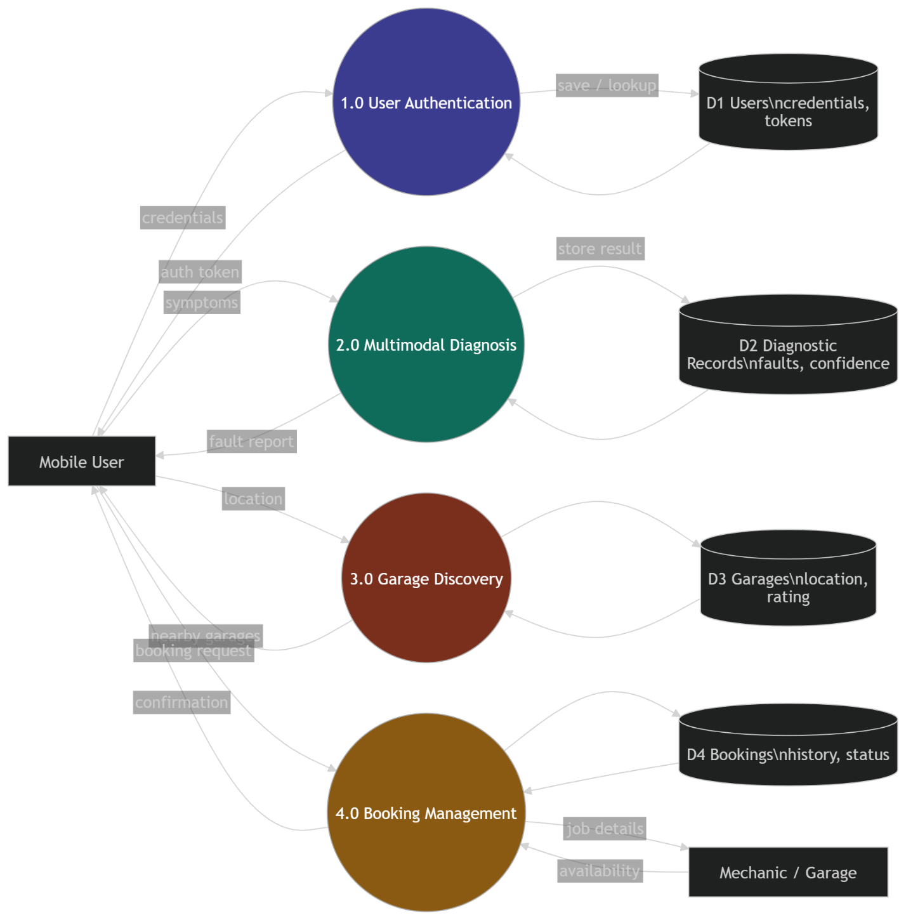
Figure 3.5: Level-1 Data Flow Diagram for the AutoAid system

3.8 Logical Design

3.8.1 System Architecture
AutoAid adopts a layered client-server architecture consisting of four layers: the Presentation Layer, the Application Layer, the Intelligent Processing Layer, and the Data Layer. This architecture is illustrated in Figure 3.6.
The Presentation Layer is the native Android application, built in Java using Android Studio. It is responsible for capturing user inputs, rendering diagnostic results, displaying garage maps, and managing user interactions. The application communicates with the backend exclusively through RESTful HTTP requests using the Retrofit library.
The Application Layer is the FastAPI backend, which exposes a set of RESTful API endpoints for authentication, diagnosis, garage discovery, and booking management. It validates incoming requests, coordinates the ML inference service, and manages all business logic. The backend uses SQLAlchemy as an Object Relational Mapper (ORM) to interact with the PostgreSQL database.
The Intelligent Processing Layer contains the ML inference engine, implemented as a Python module within the FastAPI application. In the current prototype, the inference engine uses a rule-based NLP approach to classify fault descriptions into diagnostic categories. The module is designed with clearly defined interfaces to allow replacement with trained CNN, NLP, or CNN-LSTM models without modifying the rest of the system.
The Data Layer is a PostgreSQL relational database that stores user profiles, vehicle records, garage data, diagnostic records, and booking information. The database schema is described in Section 3.9.1.

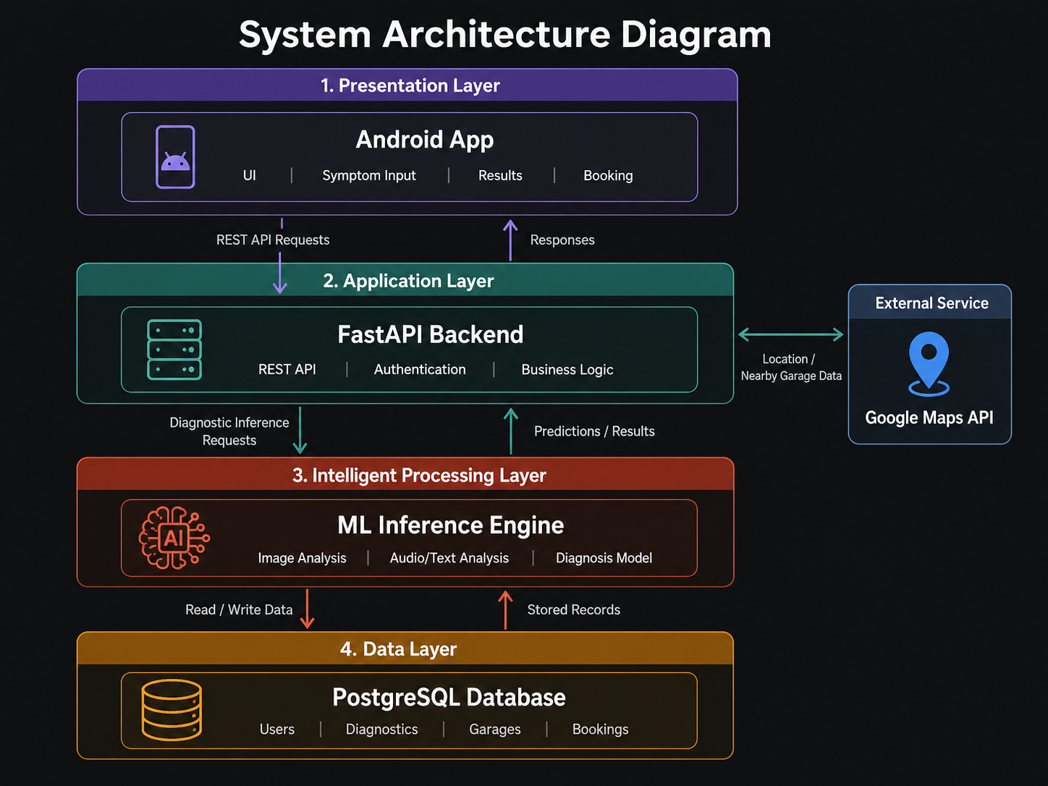
Figure 3.6: Four-layer system architecture of the AutoAid system

3.8.2 Class Diagram
Figure 3.7 presents the analysis class diagram for the core domain entities of the AutoAid system.

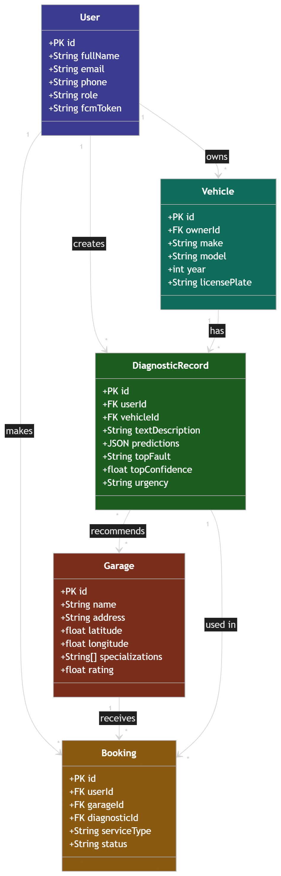
Figure 3.7: Analysis Class Diagram for the AutoAid system

3.8.3 Control Flow and Process Design
Figure 3.8 presents the activity diagram for the core diagnostic workflow, which is the primary user journey in the AutoAid system.

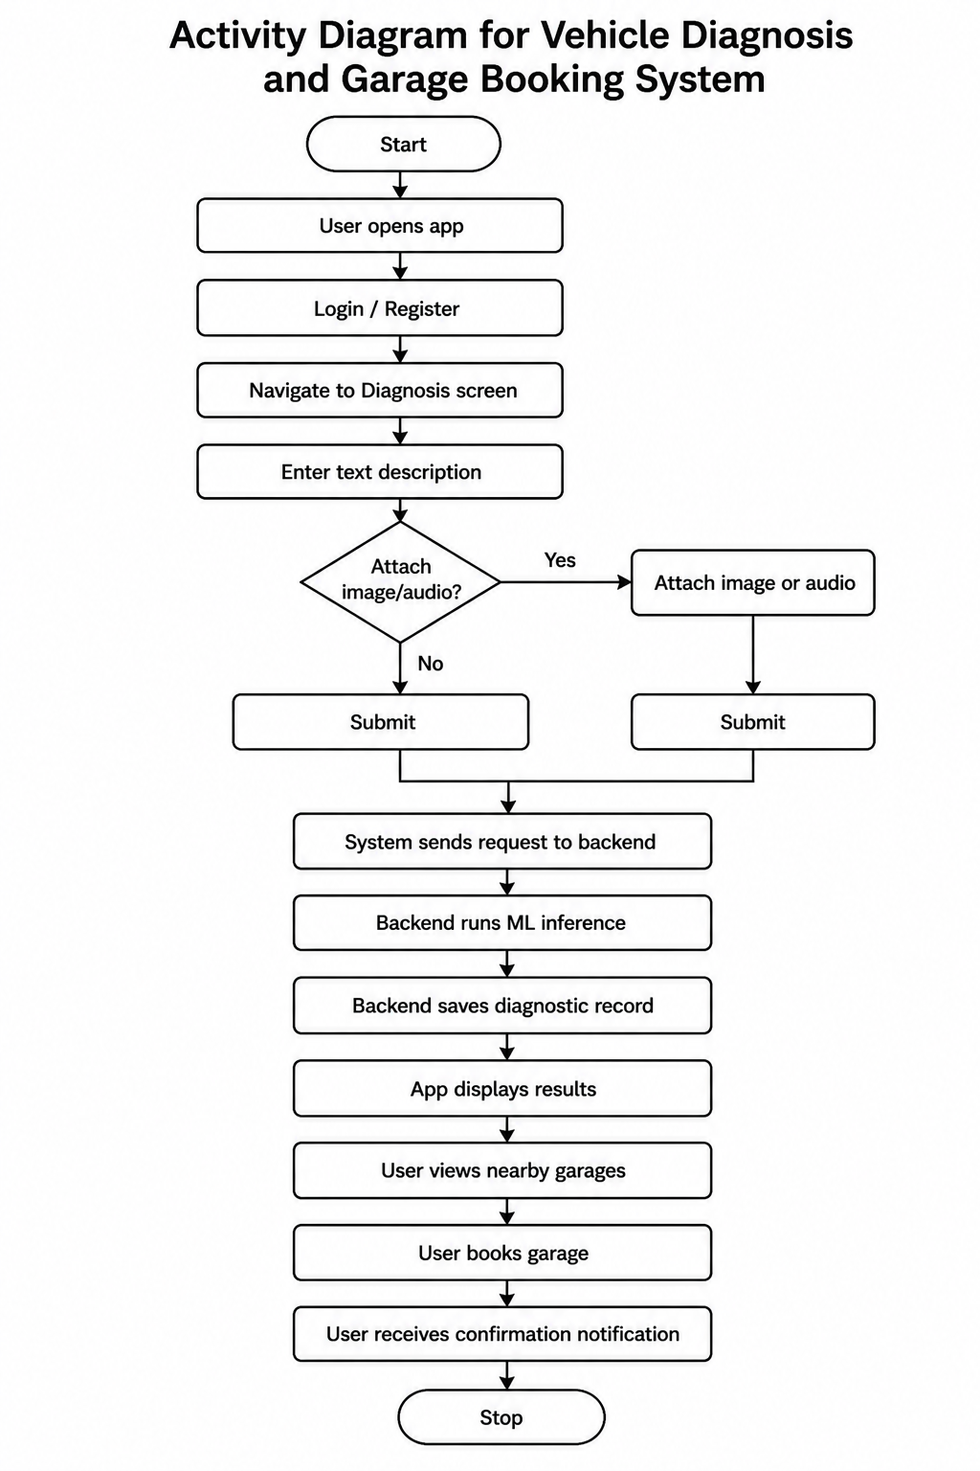
Figure 3.8: Activity Diagram for the AutoAid diagnostic and booking workflow

Figure 3.9 presents the sequence diagram for the diagnosis submission process, showing the interaction between the Android application, the FastAPI backend, the ML inference engine, and the database.

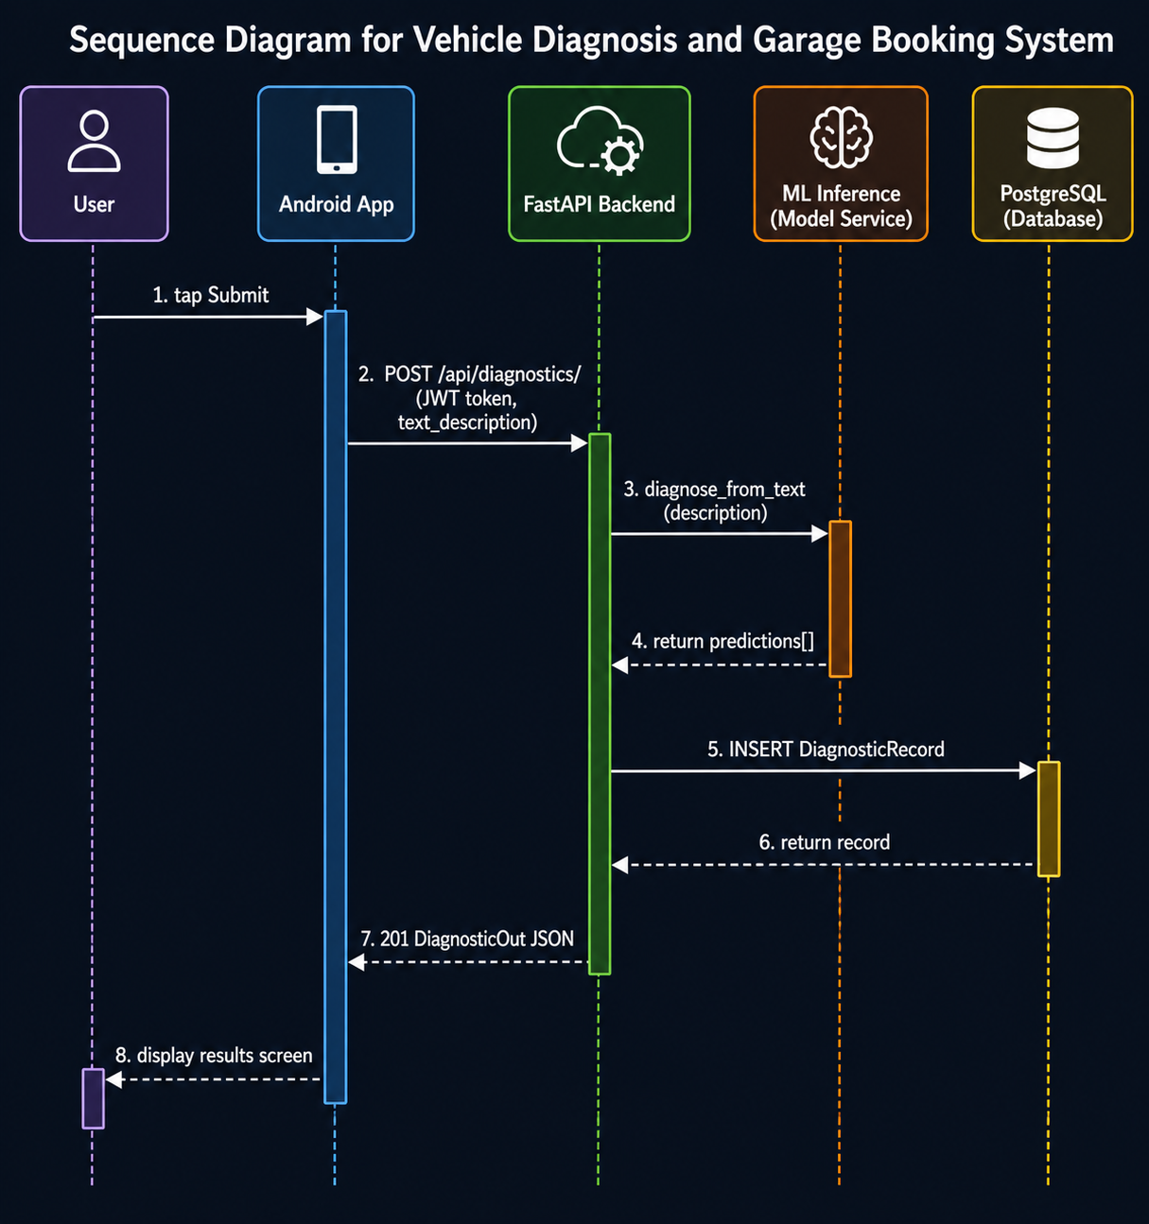
Figure 3.9: Sequence Diagram for the AutoAid diagnosis submission process

3.8.4 Design for Non-Functional Requirements
Security is enforced at the API level through JSON Web Token (JWT) authentication. All endpoints except registration and login require a valid Bearer token in the Authorization header. Passwords are hashed using the bcrypt algorithm with a salt factor of 12 before storage. The Android application stores the JWT token in SharedPreferences using the SessionManager utility class.
Error handling is implemented at multiple levels. The FastAPI backend returns structured JSON error responses with appropriate HTTP status codes for all failure scenarios. The Android application observes error LiveData from the ViewModel and displays user-friendly messages through Snackbar notifications. Network timeouts are configured with 20-second connection timeouts and 30-second read and write timeouts.
Data integrity is enforced through database-level constraints, including unique constraints on email addresses and foreign key relationships between all related entities. SQLAlchemy’s ORM layer provides an additional layer of validation before data reaches the database.

3.9 Physical Design

3.9.1 Database Design
The AutoAid database consists of five primary tables: users, vehicles, garages, diagnostic_records, and bookings. The Entity Relationship Diagram is presented in Figure 3.10.

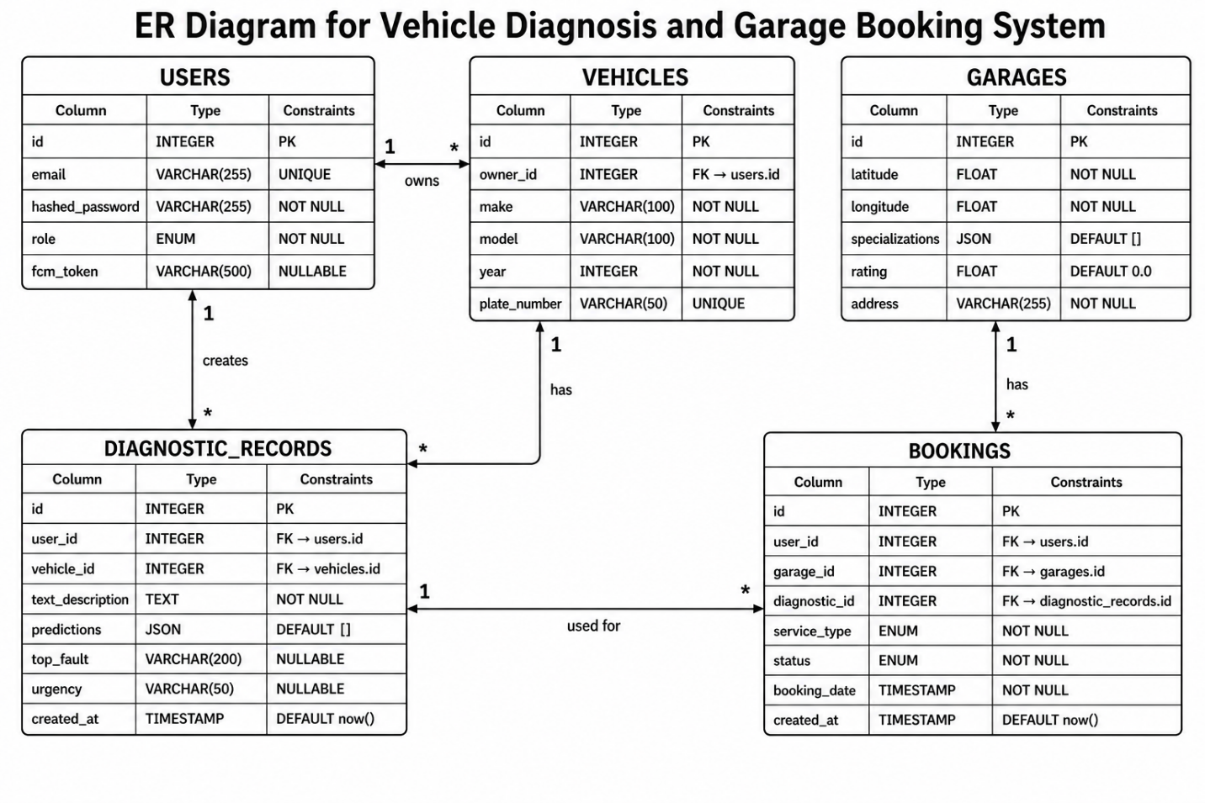
Figure 3.10: Entity Relationship Diagram for the AutoAid database

Table 3.1 provides the data dictionary for the five primary database tables.

Table | Column | Type | Constraints | Description
users | id | INTEGER | PK, AUTO | Unique user identifier
users | email | VARCHAR(255) | UNIQUE, NOT NULL | User email address
users | hashed_password | VARCHAR(255) | NOT NULL | bcrypt hash of password
users | role | ENUM | NOT NULL | driver, mechanic, or admin
users | fcm_token | VARCHAR(500) | NULLABLE | Firebase push token
vehicles | id | INTEGER | PK, AUTO | Unique vehicle identifier
vehicles | owner_id | INTEGER | FK -> users.id | Vehicle owner reference
vehicles | make | VARCHAR(100) | NOT NULL | Vehicle manufacturer
vehicles | model | VARCHAR(100) | NOT NULL | Vehicle model name
diagnostic_records | id | INTEGER | PK, AUTO | Unique record identifier
diagnostic_records | user_id | INTEGER | FK -> users.id | Requesting user
diagnostic_records | text_description | TEXT | NULLABLE | User's fault description
diagnostic_records | predictions | JSON | DEFAULT [] | ML output array
diagnostic_records | top_fault | VARCHAR(200) | NULLABLE | Highest confidence fault
diagnostic_records | urgency | VARCHAR(50) | NULLABLE | low/medium/high/critical
garages | id | INTEGER | PK, AUTO | Unique garage identifier
garages | latitude | FLOAT | NOT NULL | GPS latitude
garages | longitude | FLOAT | NOT NULL | GPS longitude
garages | specializations | JSON | DEFAULT [] | List of fault specialisations
garages | rating | FLOAT | DEFAULT 0.0 | Running average rating
bookings | id | INTEGER | PK, AUTO | Unique booking identifier
bookings | status | ENUM | NOT NULL | pending/confirmed/in_progress/completed/cancelled
bookings | service_type | ENUM | NOT NULL | garage_visit/on_site/towing

Table 3.1: Data Dictionary for AutoAid Database Tables

3.9.2 User Interface Design
The user interface of AutoAid was designed following Android Material Design guidelines. The application consists of ten screens covering the full user journey from authentication through diagnosis to garage booking. Figure 3.11 presents the wireframes for the primary screens of the application.

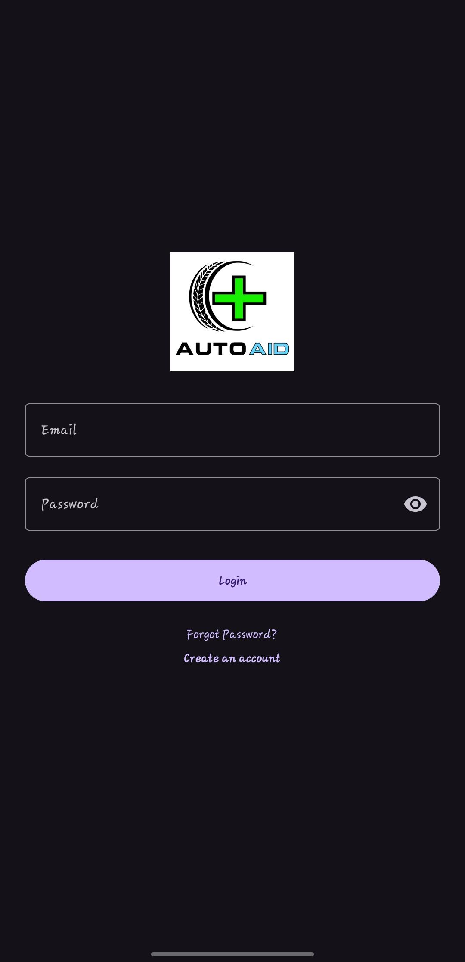
Figure 3.11a: Wireframe of the Login screen
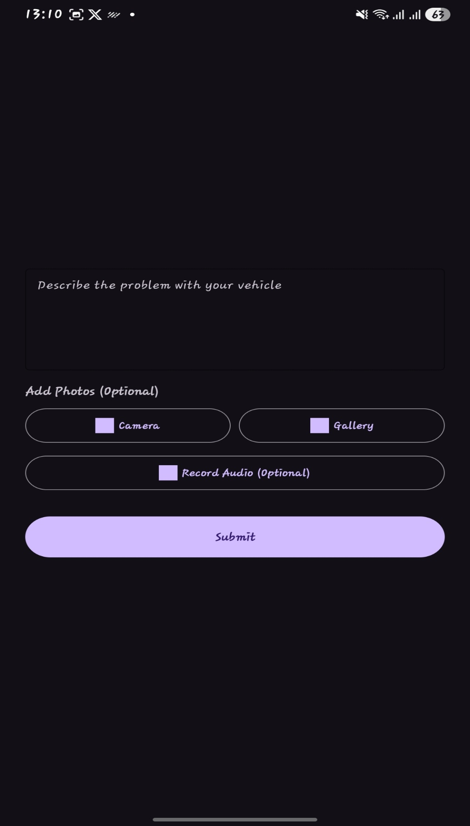
Figure 3.11b: Wireframe of the Diagnosis screen

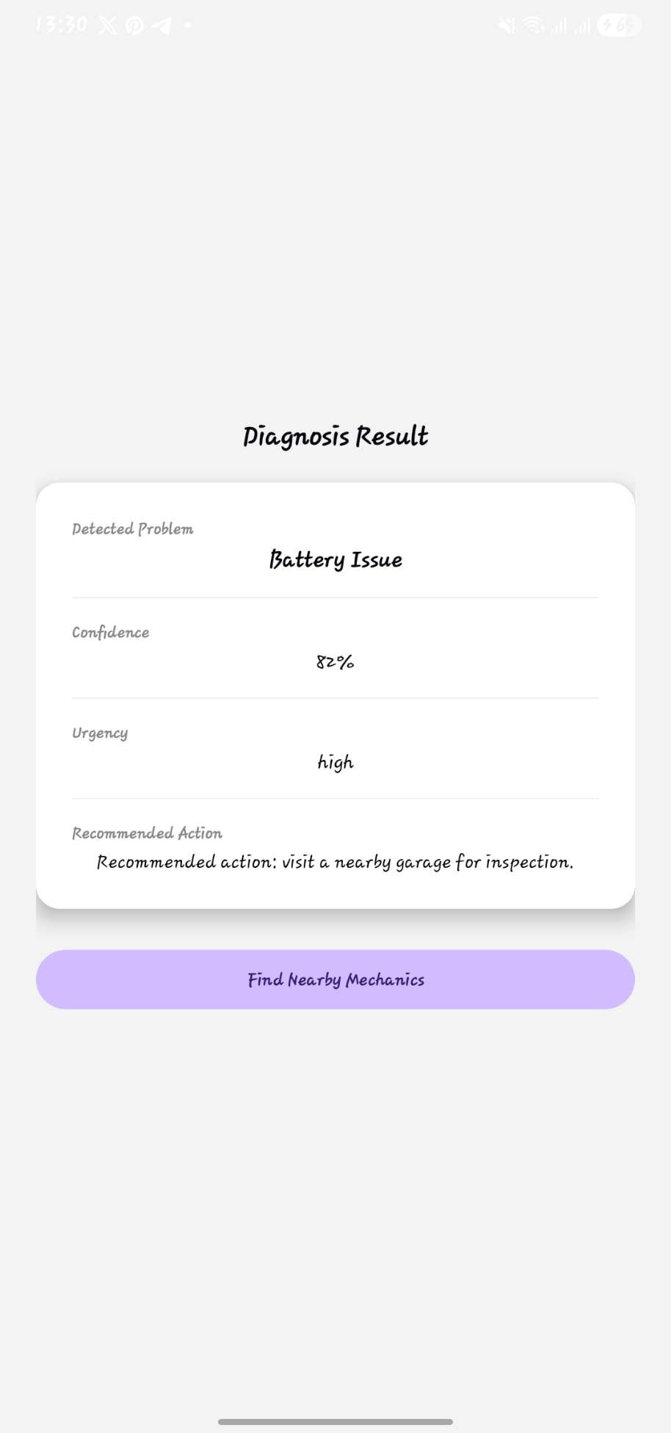
Figure 3.11c: Wireframe of the Diagnosis Result screen

[INSERT SCREENSHOT: Wireframe: Mechanics Map Screen - showing Google Map with garage markers, list of nearby garages below map showing name, distance, rating, and specialisations]
Figure 3.11d: Wireframe of the Nearby Garages map screen

